EXPERIMENT – 12 Demonstrate virtualization by Installing Type-2 Hypervisor in your device, create and configure VM image with a Host Operating system (Either Windows/Linux), using VMware workstation

**Aim**:

To demonstrate virtualization by installing a Type-2 Hypervisor (VMware Workstation) and creating/configuring a Virtual Machine (VM) with a host operating system (Windows/Linux).

**Procedure:**

1. Installed **VMware Workstation (Type-2 Hypervisor)** on the host device.
2. Launched VMware Workstation and selected **“Create a New Virtual Machine.”**
3. Configured VM settings:
   * Allocated CPU cores and RAM.
   * Assigned virtual hard disk size.
   * Chose installation media (ISO image of Windows/Linux).
4. Installed the chosen operating system (e.g., Ubuntu Linux / Windows 10) inside the virtual machine.
5. Configured **network settings** (NAT/Bridged) for internet access inside the VM.
6. Installed **VMware Tools** for better performance and integration with the host.
7. Tested the VM by launching applications and verifying that it works independently of the host OS.

Output:

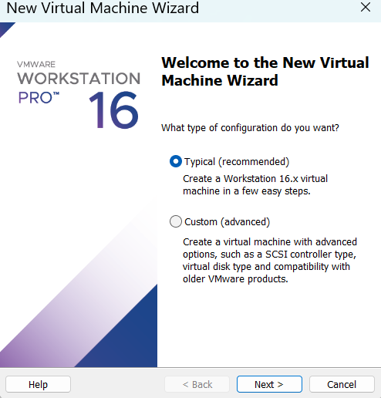

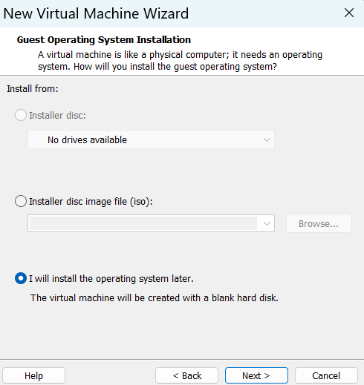

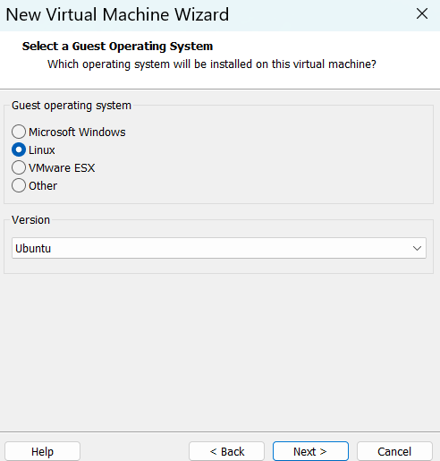

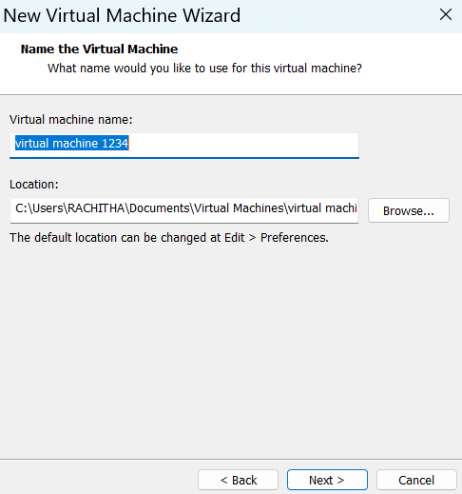

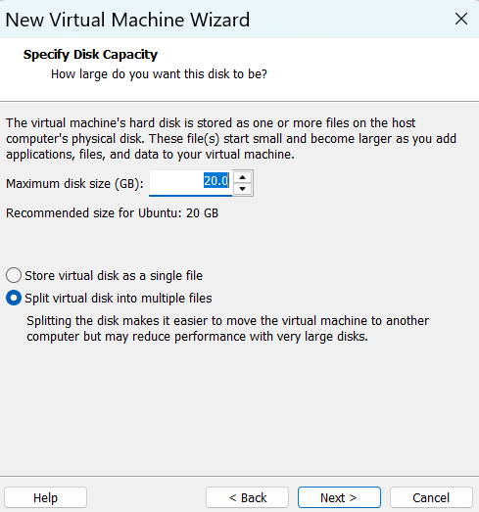

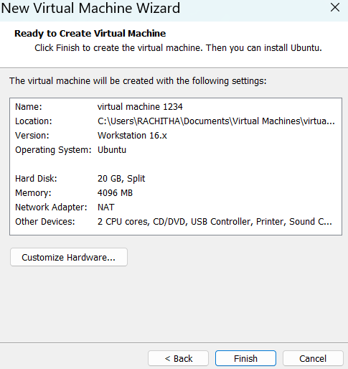

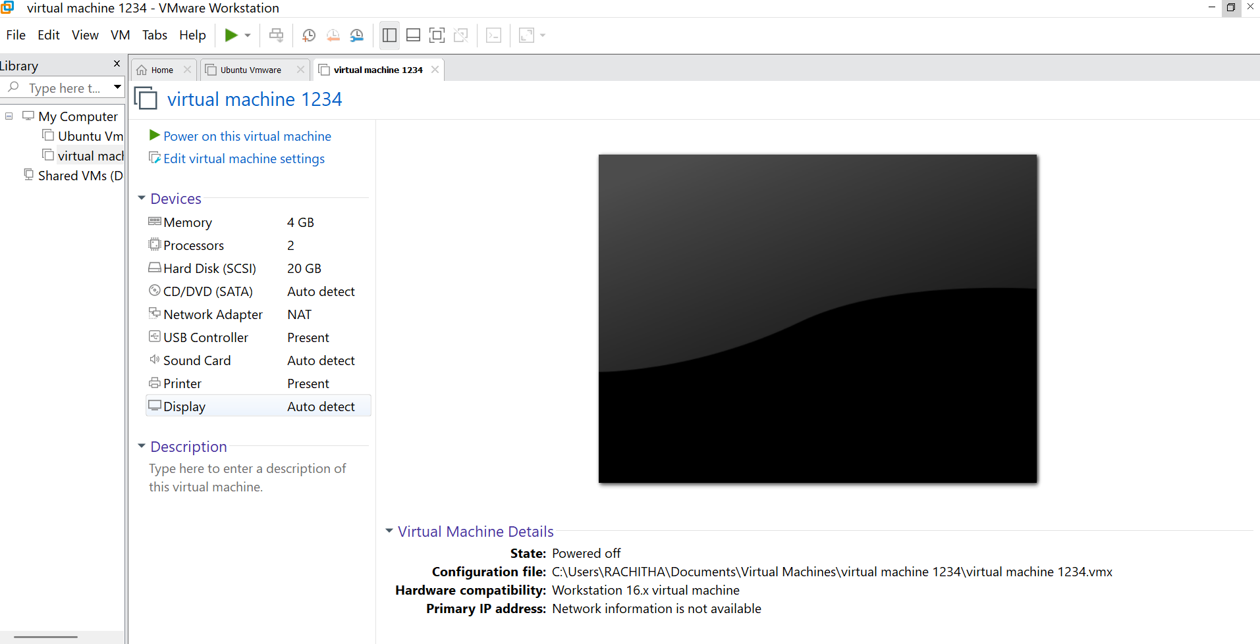

Result:

Virtualization was successfully demonstrated using VMware Workstation (Type-2 Hypervisor). A fully functional virtual machine with the selected operating system was created and configured, proving the concept of running multiple OS environments on a single physical device.